**3 - R710 Proxmox Install**

The following steps came from info in document : proxmox – steup notes.txt

(Review it if any of these steps fail) (It covers getting files to create DVD's or USB install, etc)

Steps:

1. Before installing:

Ensure Virtualisation Technology is enabled in bios ...

Enable it, and reboot into bios to check that it is still enabled.

=> if it is not enabled, then do the NVRAM clear process (see other documents)

1. When installing:

May need to adjust initial settings for disc allocation, such that root is a lot less than 60GB and swap is a lot less than 8GB

You will need to provide a valid email address during install, for proxmox to send alerts to.

As the system has previously been set up with RAID 10 for all 4 disks, they will appear as just one disk, namely ‘sda’ for proxmox to install on to.

Click options next to this and select XFS as the file system, (better for parallel stuff & better MongoDB performance with fast SSD's – if used in future)

Configure country.

passwords: <whatever>

Use first of 4 ethernet ports for management

Hostname: <whatever> [to reflect the proxmox “node” name]

**NOTE**: The hostname is used in proxmox to hang lots of settings off, and changing  
 it later will break things … so be sure to set it now to what you really want.

IP address 192.168.124.**ppn**

netmask: 255.255.255.0

gateway: 192.168.124.1

DNS: 8.8.8.8

1. After install, log in via Firefox browser on: https://192.168.124.<**ppn**>:8006

Click on Advanced, and then Click on ‘Accept the Risk and Continue’.  
 (warnings due to it using its own self signed certificate)

1. You will be presented with an annoying ‘nag’ regarding subscription …  
   Close its pop-up, Click on name of node under Datacenter and Click on “Updates” and if a list is returned similar to:  
   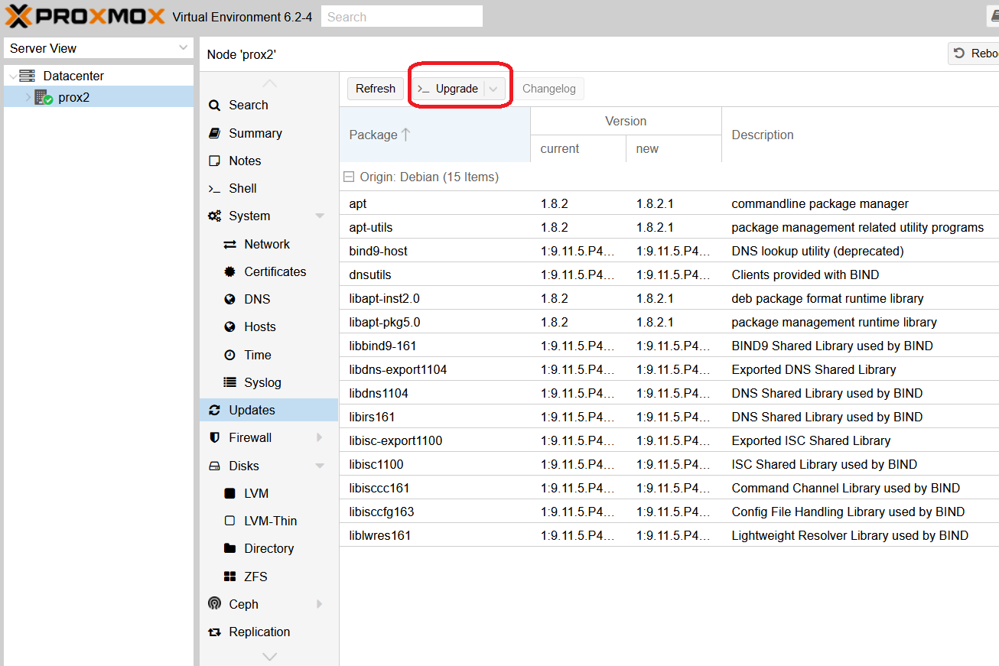, click on Upgrade (circled in RED above).  
   A window pops open similar to:  
   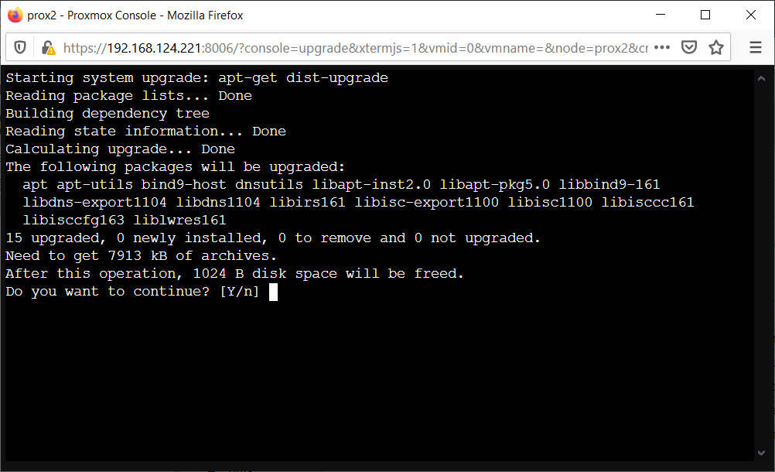

Press: Y <Enter>  
Once update finished, enter: exit  
and close the Terminal window.  
Click on the Refresh button, to see annoying “nag”.  
[add screen capture here of the update list, and a capture of the update progress]

1. Removing annoying nag for subscription:  
   See github project:  
    <https://github.com/foundObjects/pve-nag-buster>  
   and read over it to be sure it is what you want …  
   This came from: ~21+ mins into vid : <https://www.youtube.com/watch?v=tASVYJg6qQk>  
   (Watch it before performing the rest of this section, which is slightly modified)  
     
   For each proxmox node, click on Shell (to be given a root terminal) and do:  
    apt install git  
    git clone <https://github.com/foundObjects/pve-nag-buster.git>

cd pve-nag-buster  
Use nano to edit “install.sh” and comment out the two lines for ‘wget …’ to disable any future unwanted mod’s, as per:  
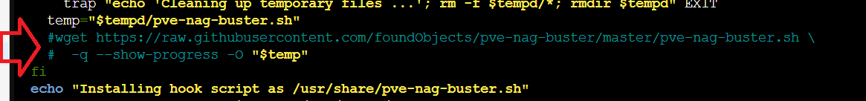   
Save changes with: CTRL O

Exit nano with: CTRL X  
(NOTE: If this breaks the script for you, fix …)  
Next enter:  
 ./install.sh  
Wait 30 seconds, and if the command prompt has not returned, reboot the node and try running the install script again.  
If you don’t do this, the next time you Click Refresh you will get something like this:  
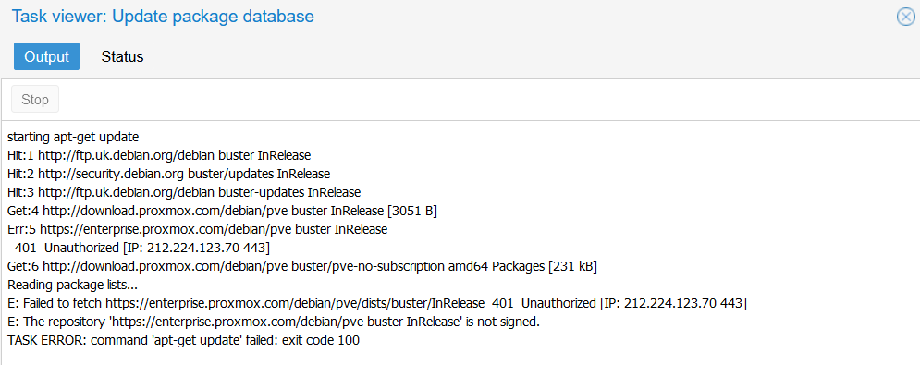

Then, in the browser, logout of Proxmox, hold down the SHIFT key and click on the browsers refresh button to clear its client side cache of the javascript that was previously downloaded that is part of the pop-up nag window.  
When things are OK, you should get something like this: 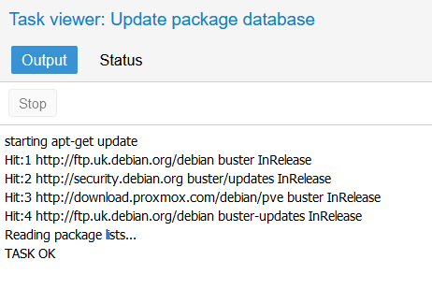

Doing another update (some days later) will hopefully (if there are any updates from the pve-no-subscription list) show …

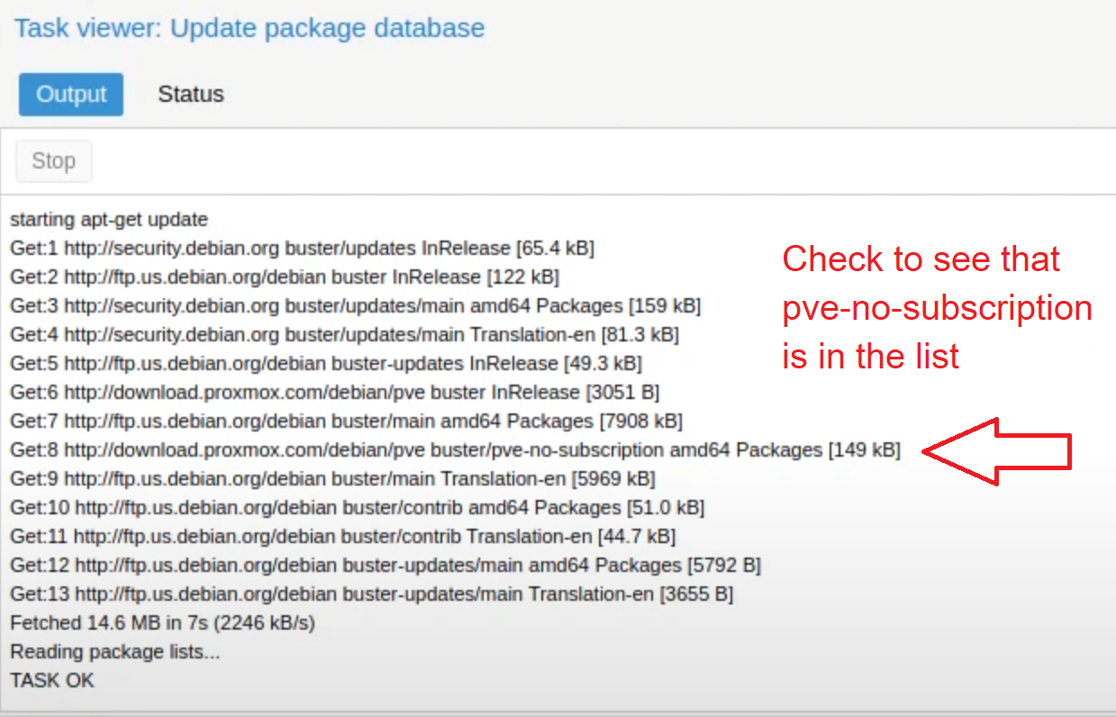

1. Dark theme: <https://github.com/Weilbyte/PVEDiscordDark>